Keats, Jonathon. “In Head-To-Head Exhibitions, Artist Rebecca Horn Equips
Machines To Fiddle With Human Emotions,” Forbes. June 17, 2019.

When Rebecca Horn was in art school, she used fiberglass and polyester as sculptural materials. They soon damaged her lungs, forcing her to spend a year in a sanitarium. The months of isolation led to a reappraisal of her sculptural medium. After she was released, she started sculpting own body.

The corpus of work Horn has created over the following half century is now on view in concurrent retrospectives at the Museum Tinguely in Basel and the Centre Pompidou-Metz. Together the exhibits and accompanying catalogues show how she has creatively expanded a relatively simple premise into a whole universe of prosthetics and robotics that explore the gamut of corporeal experience.

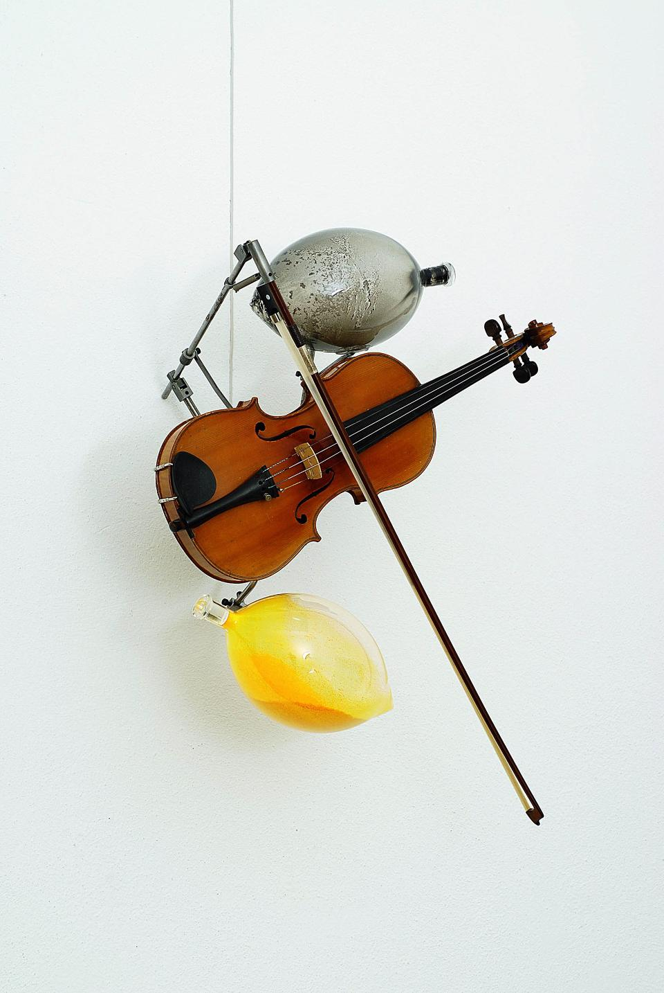
Rebecca Horn, Der Sonnenseufzer, 2006. Rebecca Horn Collection. © 2019: Rebecca Horn/ProLitteris, Zürich
In the earliest works, envisioned when she was still in the hospital and could only draw and sew, she established a range of physical movement with the inquisitiveness of someone who has been still for a long time and must find herself anew. Appendages made of fabric facilitated this bodily reawakening. In some cases, they exaggerated her appendages, such as the length of her fingers, as if to amplify the physical feedback involved in reaching and holding. In other instances, they document her actions, as was the case with a face mask studded with pencils. Finally there were prosthetics that took her beyond the human repertoire, inducing fantastical actions such as the opening and closing of wings.

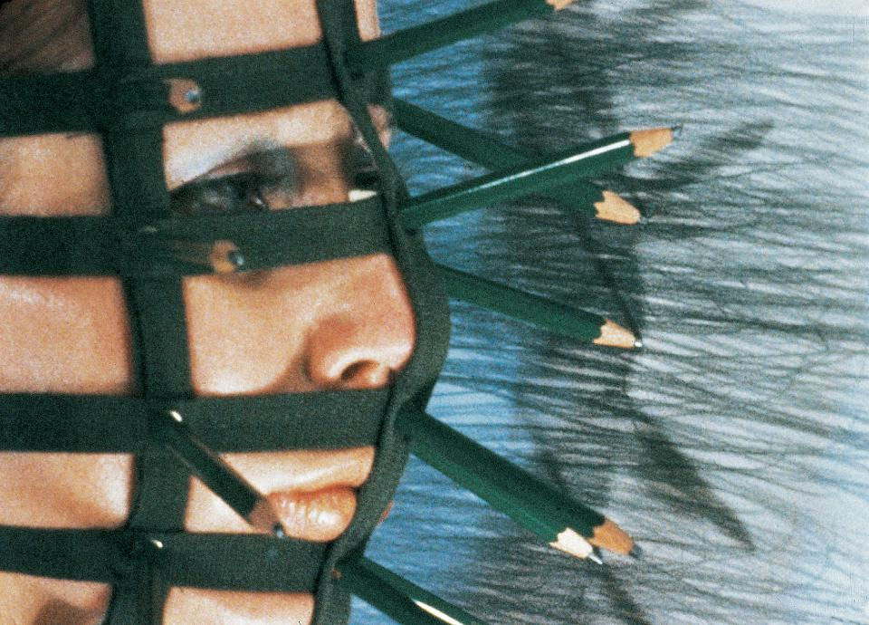
Rebecca Horn, Pencil Mask, 1973 (Filmstill). 16 mm (digitised), color, sound. Rebecca Horn Collection. © 2019: Rebecca Horn/ProLitteris, Zürich
Simultaneously with her own performances, Horn enlisted other people to wear prosthetics she made for them. The most famous of these works – and the work with which she is still most often associated – transformed a fellow art school student into a unicorn. Horn was fascinated by the woman's awkward gait, which the prosthetic horn naturally intensified, and the awkwardness was further increased by the fact that the woman was naked except for the wrappings that held it in place.

Horn's raw curiosity about movement – and the interface between the body and the surrounding world – has led to a sophisticated vocabulary of motion that is now enacted by machines instead of people. The machines extend the methodology begun with the unicorn performance, in which a physical action induced an emotion, communicated to the viewer by bodily demeanor. As Horn explained in a 1997 interview, "the sculptures are living experience crystallized into a kind of chemical formula." In addition to physiology, she attempts to crystallize psychology through programmed imperfections such as trembling and shaking.

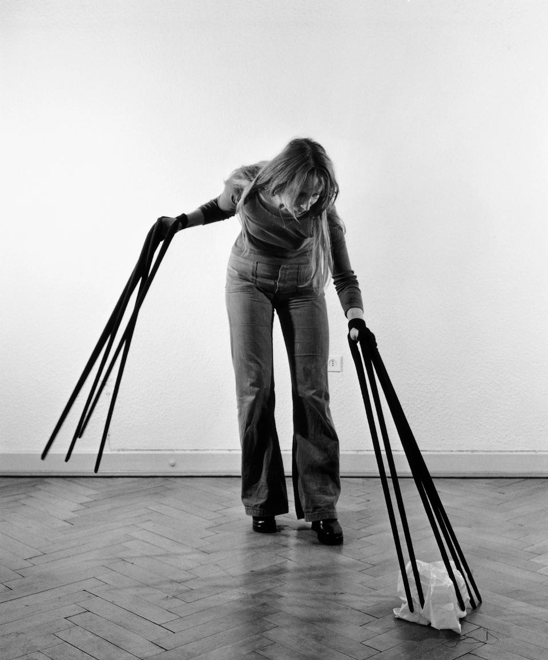
Rebecca Horn, Finger Gloves, 1972. Photography. Rebecca Horn Collection. © 2019: Rebecca Horn/ProLitteris, Zürich

At the same time, the machines challenge the empathy induced by physical observation. For Horn, the mechanisms "have a soul", but the soul is obviously a simulation. In other words, the empty-headed robots encourage us to reflect on how much we project our emotions onto other humans. (Was her horned classmate feeling awkward, or is the awkwardness our own?) The machines induce psychological uncertainty and emotional disorientation. In a roundabout way, the viewer encounters emotional isolation evocative of Horn's experience in the sanitarium.

Granted, the intensity is lower, and free of the physical pain she had to endure. However Horn's automated sculpture stands as an invitation to assume less and to take stock of routine activities. Perhaps even to reestablish contact with the world, wearing supersized appendages.

